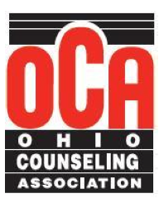
2014 OCA Leadership Institute Packet
Table of Contents
Strategic Planning………………………………………………………............2
Motivating Volunteers………………………………………………………….3
Media Resource Guide………………………………………………………….4
OCA Chapter/Division Contact Sheet………………………………………….5
Event and Continuing Education Planning………………..……………………7
OCA Chapter/Division Missions and Goals…………………………………..10
Strategic Planning/Missions

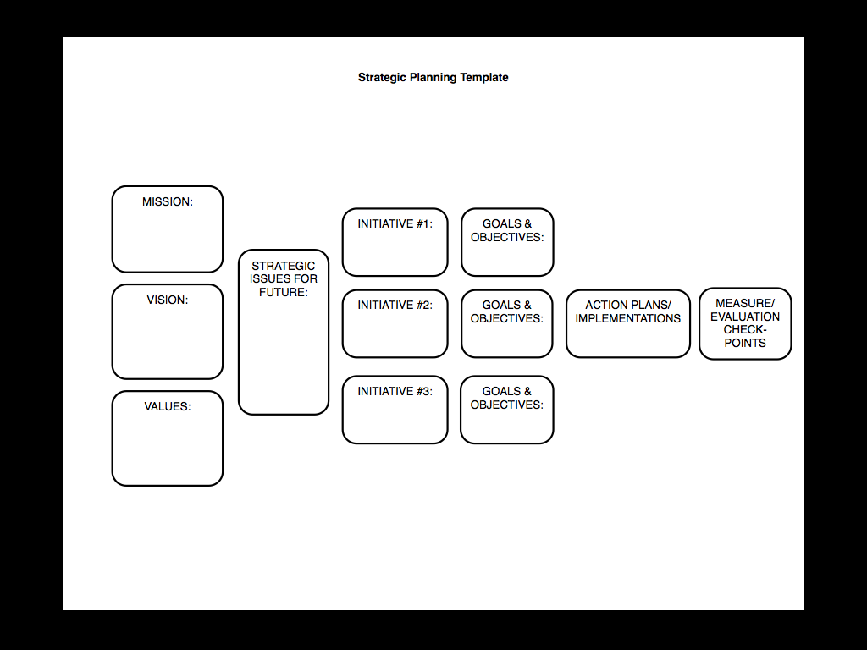

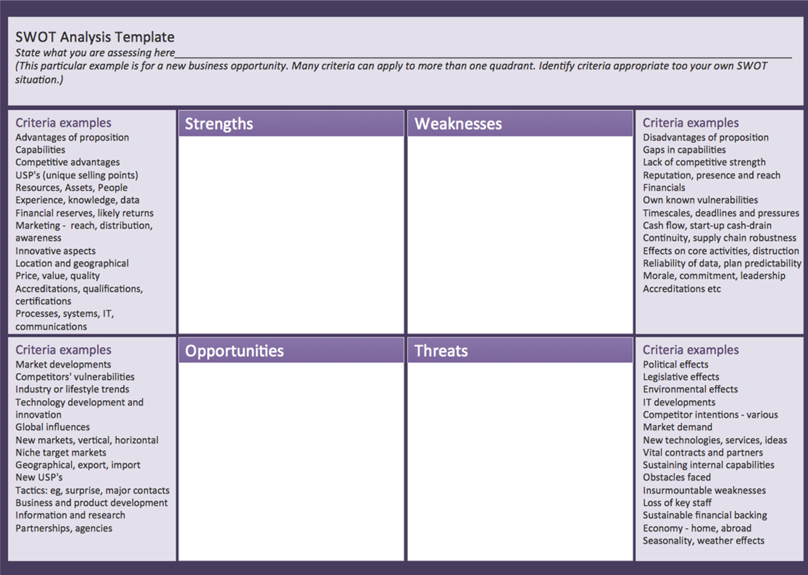
Meghan Fortner
http://samburke.wordpress.com/2011/05/10/strategic-planning-made-simple-kind-of/

Tips for Motivating Volunteers

Consider which of the following six personal/social functions are primarily motivating an OCA member to serve, and then show how OCA serve can meet that need. Continue to reinforce that motivating factor throughout their service.
Values – I volunteer in OCA to take action expressing a value (e.g., advocacy) important to me.
Understanding – I volunteer in OCA to learn more about OCA / counseling profession.
Enhancement – I volunteer in OCA because it challenges me to personally grown and develop.
Career – I volunteer OCA to gain career-related experience.
Social – I volunteer in OCA to strengthen my social relationships.
Protective – I volunteer in OCA to keep myself busy and distracted from other issues in my life. (Clary & Snyder, 1999)

Reinforce secondary benefits of volunteering for OCA members:
Develop OCA friendships;
Feel a sense of belonging to OCA;
Express one’s own personality/creativity through service in OCA. (Shye, 2009)

Increase OCA Organization-Based Self-Esteem in Volunteers. OCA leaders should create a culture where volunteers report the following – “I count”, “I am taken seriously”, “I am important”, “I am trusted”, “There is faith in me”, “I can make a difference”, “I am valuable”, “I am helpful”, “I am efficient”, & “I am cooperative”. (Pierce, Gardner, Cummings & Dunham, 1989)

Utilize General Strategies to Motivate OCA volunteers:
Build a relationship with your volunteers
Show how the volunteers’ service makes a difference to members in OCA / clients.
Highlight how volunteering in OCA can create career opportunities
Help volunteers feel included / ownership of tasks.
Provide proper training/expectations for volunteers.
Offer volunteers flexibility for level of involvement (low/high commitment).
Share accomplishments and milestones of volunteers.
Reward and recognize volunteers with something they would appreciate.
Be available to your volunteers and communicate regularly.
Create an environment for volunteers to have fun with tasks / projects
Recruit OCA leaders that collaborate well with volunteers (McKee, 2014 & Score, 2013)

Jake Protivnak
OCA Leadership Institute – November 2014

Media Resource Guide

Below is a list of resources covered in the presentation. These sources will link you to pricing information (where applicable), tutorials, product information, and free trials of most of the software covered. Please do not hesitate to contact the OCA media committee with questions! OHcounseling@outlook.com

Google Docs (file sharing through Google) https://docs.google.com

DropBox (File sharing) https://www.dropbox.com/

Hightail (Advanced file sharing) https://www.hightail.com/

Google Calendar (scheduling through Google) https://www.google.com/calendar

Doodle (online meeting tool) http://doodle.com/

Free Conference Call (online meeting scheduler/creator) https://www.freeconferencecall.com/

Skype (video conferencing) https://www.skype.com

Go To Meeting (online meeting creator/scheduler) https://www.gotomeeting.com

Zamzar (online file conversion) https://www.zamzar.com

OCA Chapter/Division Contact Sheet 2014/2015

Ohio Mental Health Counseling Association (OMHCA)- http://www.ohmhca.org/
President- Gregory Pollack; glp12@zips.uakron.edu

Ohio Career Development Association (OCDA)- http://ocdaonline.org/
President- Ryan Wilhelm, MA, LPC; wilhelm.118@osu.edu

Ohio School Counselor Association (OSCA)- http://www.ohioschoolcounselor.org/
President- Sara Williams; sarawilliams@ohioschoolcounselor.org

Ohio Association for Specialists in Group Work (OASGW)- https://www.facebook.com/OASGW/info?ref=stream
President- Kelly Kozlowski; kkozlow@bgsu.edu

Ohio Association for Counselor Education and Supervision (OACES)- http://oaces.org/
President- Christie Jenkins; jenkinschristie@aol.com

Central Ohio Counseling Association (COCA)- http://www.centralohiocounseling.org/
President- Jane Dooley; jane@janedooleycounselingsolutions.com

Eastern Ohio Counseling Association (EOCA)- http://www.eoca.info/
President- Jamie Sitko; jsitko@kent.edu

Miami Valley Counseling Association (MVCA)- http://mvca.info/
President- Amita Pujara; amita.pujara@wright.edu

Northwest Ohio Counseling Association (NWOCA)- http://site.nwohiocounseling.com/
President- Ryan Pickut; pickut@hotmail.com

Southeastern Ohio Counseling Association (SEOCA)
President- Pam Johnson; pamjohnson.lpccs@gmail.com

North Central Ohio Counseling Association (NCOCA)
President- Martha Flemming; nscounsel@sbcglobal.net

Greater Cincinnati Counseling Association (GCCA)- http://www.cincycounseling.org/
President- David Brown; david.brown@ccuniversity.edu

Association for Lesbian, Gay, Bisexual, & Transgender Issues in Counseling of Ohio (ALGBTICO)- http://www.algbtico.com
President- Jared Rose; jaredsrose@gmail.com

Event and Continuing Education Planning
Kara Kaelber, PhD, LPCC-S Malone University
Michael S. Lewis, MA, LPCC-S Ohio Dominican University

Top ten ways to create an effective and meaningful workshop
#1 Choosing a Good Topic
What are you as a professional interested in?
Ask others what they’d like
What is marketable? What are people willing to pay for?
Does the topic fill a void?
Is it too broad or too narrow?
How does it fit with the CSWMFT Board requirements for CEUs?

#2 Picking a Qualified Presenter
Who has the expertise to present on the topic you’ve chosen?
Check around – past conferences and workshops, colleagues, & publications
Are there multiple people you’d like to invite?
Consider “interviewing” the presenter to be sure it will be a good fit

#3 Taking Care of the Presenter
Ask how they would like to be addressed in both introductions and in print
Ask them what their expectations for the day
Come to agreements on who is responsible for things like copies, A/V requests/set-up, equipment, etc. – Easy to make assumptions
Be sure to think of their needs for the day of
Check in days before the workshop to confirm and ask if there are last minute requests or questions

#4 Learning from the Past
What are the expectations of your attendees?
What are they likely to already know relative to what they want to learn?
Has a workshop similar to this topic been done? Can you gain insight from the presenter/host of that event?
Don’t have the answers to these questions? Ask! They will tell you

#5 Planning the Day
How much time will you need?
Check A/V needs – Is it provided or BYOT?
Don’t forget to add in breaks and meals (if needed)
Build in time to allow attendees to talk to one another and network
How large of a venue will you need?
Can you change the venue based on participant response?
Copies of everything
Creature comforts - Anticipate what attendees will want and need

#6 Targeting your Audience
Who is most likely to enjoy or need the workshop you’re hosting?
How do you reach them directly?
Mailers, flyers, emails, phone calls, Facebook, Twitter, OCA postings, online forums, word-of-mouth……
What is the most effective use of your time, money, and resources
It doesn’t matter how many people you reach if you reach the wrong ones

#7 Having a Marketing Strategy
Make sure people know exactly who, what, when, and where
Avoid being too wordy or using jargon.
Don’t forget to add contact information should people have questions
Avoid copyright infringement – check any photos and pictures you use.
Keep your desired audience in mind
Make the description congruent with the actual experience
Use logos – OCA and your represented organization

# 8 Planning Ahead
Send materials into the OCA Professional Development Committee early
Helps identify potential issues before they become issues
Gives time to promote and market successfully

#9 Avoiding Common Pitfalls
Overlooking competing events
Not having a contingency plan
Not having enough help for workshop day
Undefined goals
Speaker’s expertise doesn’t match topic and/or attendees wants
Not checking the speakers credentials
Lack of vision for the day
Not taking time to familiarize yourself with everything
The topic doesn’t meet the attendees where they are
Not allowing enough time to set-up before people arrive
Poor registration process
Not having good signage at the venue (parking lot, lobby, registration, etc.)
Failing to thank presenters and attendees

#10 Planning for the Future
Ask for feedback
Use the OCA Evaluation template
Add any specific questions you’d like to know
Talk to attendees right after the class
Follow-up with attendees a few weeks later
Elicit feedback from stakeholders (presenter, co-hosts)
Personally evaluate what went well and what needs improvement
Record these thoughts, ideas, data for later use (by you and others)
Examples of OCA Chapter/Division
Missions or Purposes

Association of Lesbian, Gay, Bisexual and Transgender Issues in Counseling of Ohio (ALGBTICO)
The mission of ALGBTICO is to promote greater awareness and understanding of lesbian, gay, bisexual, and transgender (LGBT) issues among members of the counseling profession, students, the clients they serve, and related helping occupations. ALGBTICO also promotes greater awareness and understanding of persons of various sexual and/or affectional identities not represented within the identities presumed by “LGBT” such as queer, intersex and ally.

Central Ohio Counseling Association (COCA)
COCA serves professional counselors and students in counseling programs in the Central Ohio region. Our mission is to enhance human development across the life span while assisting counselors and the counseling profession to develop higher levels of visibility and stature. COCA also helps promote professional identity, recognition, and development

The Ohio Mental Health Counselors Association (OMHCA)
The Ohio Mental Health Counselors Association (OMHCA) provides professional information, education, training, and advocacy for Mental Health Counselors in Ohio. OMHCA is a vital and effective organization in advocating for the provision of a broad range of services to meet the mental health counseling needs of consumers in the Commonwealth.

Ohio Association for Specialists in Group Work (OASGW)
As Counseling Professionals who are interested in and specialize in group work, we value the creation of community; service to our members, their clients, and the profession; and leadership as a process to facilitate the growth and development of individuals and groups.
The purpose of the Association shall be to establish standards for professional and ethical practice; to support research and the dissemination of knowledge; and to provide professional leadership in the field of group work. In addition, the Association shall seek to extend counseling through the use of group process; to provide a forum for examining innovative and developing concepts in group work; to foster diversity and dignity in our groups; and to be models of effective group practice.

Ohio Association for Counselor Education and Supervision (OACES)
The purpose of this organization is to advance the preparation, life-long professional development, and supervision of counselors and to enhance counseling services in all settings.

Ohio Career Development Association (OCDA)
The purpose of the Ohio Career Development Association is to promote a greater understanding of the meaning of work and vocation, to foster career development over the life span, and to improve the standards of professional service in the field of career guidance and counseling in Ohio.

Northwest Ohio Counseling Association (NWOCA)
To enhance human development across the life span while assisting school counselors and mental health counselors to develop higher levels of visibility and stature. We'll help promote professional identity, recognition, and development.

Ohio School Counselor Association (OSCA)
The Ohio School Counselor Association empowers, unites and supports professional school counselors in their role of promoting student success.

Ohio Association for Spiritual, Ethical, & Religious Values in Counseling (OASERVIC)
Professional Counselors are confronted with events and discoveries that challenge our spiritual, ethical, and religious values. The mission of the Ohio Association for Spiritual, Ethical, & Religious Values in Counseling (OASERVIC) is to provide a forum for informed and thoughtful consideration of these issues and how they affect counselor education, the counseling profession and the client-counselor relationship.
OASERVIC seeks to create an association which empowers and enables the expression, exploration, development, and research involving spiritual, ethical, and religious value dimensions as they relate to the person, to society, and to the profession of counseling.
