Dear ACA Western Region Leadership Development Workshop Participant,

First and foremost – put my number in your phone – 208-869-0199. More than likely you will need it at some point, and I welcome you to call me with questions.

Thank you for registering and attending the ACA WR 2013 Leadership Development Workshop. Please read the attached agendas for the weekend – especially noting meals on your own and catered events. Though you may be here for just the Friday event, I welcome you to participate in as much as you possibly can. This is a rare opportunity for us.

I look forward to meeting with you and the other attendees on Thursday, October 7, 2013 for an informal “gathering of the minds” to discuss pertinent information specific to each branches needs. My hope is that we can collaborate and problem solve together. I will be arriving early afternoon and will meet up with you for the 6:00 meeting. Please connect with both myself and Kitty Unthank to coordinate transportation to the hotel and connection with leaders as they arrive.
Kitty - kwadeunthank@yahoo.com, 775-742-1475

Friday is a very busy day and it is much more formal in nature. I have attached the schedule of events with the breakout description for you to look over.

Saturday the 9th, the Nevada Counseling Association is hosting their fall 2013 workshop. Dr. Katherine Unthank is presenting in the morning on “Applying the Skills of Mindfulness to the Energies of Unresolved Trauma” from 9:00 a.m. – Noon. Sean Nixon and I am presenting the ethics portion in the afternoon from 1:00 p.m. – 4:00 p.m. You have the opportunity to participate by registering on the www.nvcounseling.org website. That evening, we plan to consolidate feedback received from the previous day and collaborate on future actions moving forward.

Sunday the 10th, my team and I are leaving after a Western Region breakfast to discuss any further action plans and to see each other off to our respective homes.

I hope this clarifies for you the schedule of events and you are able to participate in all. I am thrilled that you are able to join us and that Western Region is making its mark through your strong leadership.

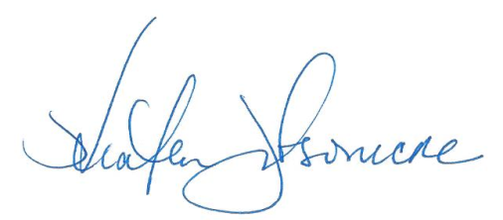
I look forward to seeing you next week.

Smiles,

Heather Tustison
ACA Western Region Chair
heathertustison@gmail.com

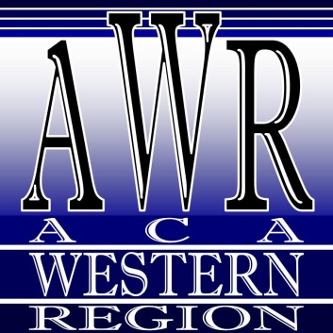
Leadership Development Workshop Schedule
Thursday, November 7, 2013

Time Function Leader
6:00 – 10:00 Meetup in Hilton Lobby All
Meeting with Western Region Leadership to rendezvous with Western Region Branch Leaders to address branch specific concerns - sharing/ collaborating/problem solving among state leaders - ie (Casting a wide net for all counselors, Avoiding burn out for leaders, Building bridges - college population, underserved, rural population)

Leadership Development Workshop Schedule
Friday, November 8, 2013
8:00 a.m. – 8:00 p.m.
University of Phoenix Northern Nevada
10345 Professional Circle, Reno, Nevada

Time Function Leader
8:00 – 9:00 Meetup/Breakfast – Catered at University of Phoenix All
9:00 – 9:30 Welcome and Introductions
9:30 – 10:30 Mission/Vision Statements Heather Tustison
Organizational Structure
Guidelines and Expectations for Leaders
A leader’s role effectiveness is determined by how they define their position, or how the position defines them. This session will describe standards set by ACA as well as Branches to help further define what a new leader may do in their current and future leadership role.
10:30 – 10:45 Break
10:45 – 12:15 Team Playing – Essential Qualities of a Leader Kendal Tucker
Getting and Retaining Leaders Heather Tustison
There are character traits of a leader that can increase team effectiveness. Many characteristics will be described and reviewed as well as encouraged in order to maintain an effective team and to bring new players to the “game.” These characteristics determine receptivity to leadership in an organization as well as maintenance in those roles.
12:15 – 1:15 Working Lunch – Catered at University of Phoenix Heather Tustison
Boosting Your Membership
Communication and Accountability
Maintaining Records/Database Options
As counselors, we are aware that effective communication, promotes understanding and investment. This session will describe effective communication strategies as well as forms of accountability to utilize in a “volunteer” organization. It will also review tools for efficiently utilizing technology to communicate with members of the organization.
1:15 – 1:30 Break All
1:30 – 3:00 How to Be a One Voice Advocate Kendal Tucker
There’s Plenty of Room at the Table Sean Nixon
Advocacy does not have to start and end at a picket line. This session will describe how a disjointed organization can see clearer by working together and speaking with one voice. It will address autonomy with unity and how that can be successful in an organization.
3:00 – 3:15 Break
3:15 – 4:45 Getting and Retaining Leaders Heather Tustison
The Five Levels of Leadership that is utilized by John Maxwell will be described and discussed. Transition from level to level will be described as well, how to “level-up” for a leader seeking a higher level of leadership.
5:00 – 6:30 Dinner at Sierra Gold Casino All
6:30 – 8:00 Effective Fundraising and Conferences Sean Nixon
There is a balance one must achieve when organizing a large educational training. Many things need to be considered, educational opportunities need to be excellent in nature, standards for that education need to be monitored, significance of the topic to the membership and how it will all be funded. This session will describe successful programs as well as give ideas and suggestions.
8:00 Closing All

Leadership Development Workshop Schedule
Saturday, November 9, 2013

University of Phoenix Northern Nevada
10345 Professional Circle, Reno, Nevada

Time Function Leader
8:00 – 9:00 Meetup/Breakfast – Hilton Garden Inn All

Nevada Counseling Association Fall 2013 Workshop

9:00 – Noon Applying the Skills of Mindfulness to the Energies of Unresolved Trauma
Katherine Unthank, PhD, LCPC, NCC
Mindfulness is a way of thinking and focusing that can help you become more aware of your present experiences. There are things done every day that we do without thinking, like getting dressed, making the bed or driving to work. Mindfulness involves paying attention to the feelings and sensations of these experiences.

This workshop will explore mindfulness techniques and interventions that may be helpful with trauma or other anxiety problems. If you have clients that have gone through trauma, you may want to learn what mindfulness is and how it might be helpful to you and your counseling.

1:00 – 4:00 Counseling Ethics - Strategies and Struggles
Heather Tustison, LCPC
Sean Nixon, LPC, LAMFT, NCC
Ethical dilemmas and professional challenges surround us on a daily basis. We hope that this workshop will provide you with the necessary tools to ensure compliance with the ethical guidelines of our profession.

Counselors may work with several different clients on a daily basis. Many potential ethical scenarios, are therefore, created. We will explore several scenarios and conclude using the American Counseling Association (ACA) Code of Ethics as a reference and guide to make ethical decisions.

5:00 – 8:00 Dinner and Social Hour at TBD All
Consolidation of feedback received from the previous day and collaborate on future actions moving forward.

