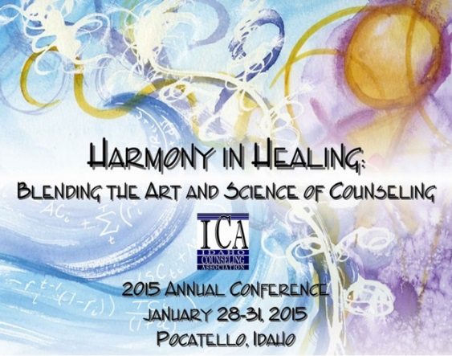
Idaho Counseling Association
Annual Conference
January 28-31, 2015

The Red Lion Convention Center

Pocatello, Idaho

Pre-Conference Learning Institute
January 28-29, 2015
Proposal Form

Cutting Edge Counseling: Connection Points for Growth

Proposal Deadline: September 15, 2014

Notification of acceptance will be sent out no later than October 1, 2014
Please note: Incomplete proposals will be returned for completion

NO more than three (3) proposals may be submitted by anyone presenter.

A passport quality photograph and any credentials are required.

NOTE: Submission of this proposal constitutes acceptance of all conditions and terms

**No more than 4 presenters per interest session please**
Presenter #1  Name:  Credentials:  Address:  City:  Phone (w)  (h)  (f)  Email:  Website: | Presenter #2  Name:  Credentials:  Address:  City:  Phone (w)  (h)  (f)  Email:  Website:
Presenter #3  Name:  Credentials:  Address:  City:  Phone (w)  (h)  (f)  Email:  Website: | Presenter #4  Name:  Credentials:  Address:  City:  Phone (w)  (h)  (f)  Email:  Website:

Title of Program: (Limit to 20 Words)

Synopsis: Program Description as you want it to appear in marketing materials. This should include:
  - Clear summary. Information, techniques, theory, or research to be presented. (Limit to 40 words.)

  - Learning Objectives. What the audience can expect to learn. (3 to 4 condensed bulleted items)
Participants will:

(i.e. * learn art therapy techniques in theory and in application)

  - Method of the presentation
Panel Lecture Debate Demonstration Q & A

  - Relation to the theme of “Harmony in Healing: Blending the Art and Science of Counseling.”

This proposal is being submitted for:  Half Day Session (4 Hours)  Full Day Session (8 Hours) | Audio-Visual Requests:  LCD Projector (will be provided)
Please check the division that would most benefit from your program:  School Counselors  Mental Health Counselors  Vocational/ Career Counselors  Marriage & Family Counselors  Counselor Educators & Supervisors  Ethics  Other: | Program Time Preference  Wednesday, Jan 28.  Thursday, Jan 29.  No Preference  What level of clinician would best served by your presentation?  Novice Professional (less than three years)  Advanced Professional (more than three years)

Please submit a brief biography for each presenter.

Please submit a passport quality photograph to be published in printed materials via e-mail. Failure to do so results in an incomplete proposal.

Special Requests or Needs:

2015 ICA Annual Conference
Pre-Conference Learning Institute Presenter Agreement

Before submitting the above proposal, Presenters please read through the following agreement and sign and date below.

- Program Coordinator will send notification of accepted proposals before October 1, 2014.

- At least one presenter must be licensed as a Counselor with the State of Idaho. Presenters are limited to presenting no more than two (2) presentations.

- All rooms are set with movable chairs, theatre style, speaker's table, LCD projector, screen and AV table.

- It is the responsibility of presenter to provide computer and any audio equipment that they might need. Including any cables required to connect to the LCD projector.

- Internet access is not guaranteed.

- Presenters agree to the possibility of videotaping interest sessions for the use of continued education for ICA members only.

- Photographs and demographic information submitted may be used for recognition on the ICA website or printed materials. Higher resolution is better, but keep images less than 1 MB if possible.

- Presenters should come prepared with at least 50 copies of handouts to be distributed to attendees.

- Presenters will receive a summary of evaluations within 30 days after the conference.

- Presenters will be listed alphabetically, unless otherwise specified in this agreement.

- Special needs or requests should be directed as soon as possible to the Program Coordinator.

- Program Coordinator will be notified as soon as possible of revisions, edits or cancellations. A letter of confirmation will be sent out by October 1, 2014 to be reviewed and accepted by presenter.

- Pre-Conference Learning Institute Presentations are eligible for a presentation per diem for the presentation, not each presenter. Per diem will be dispersed within 30 days of the completion of the Pre-Conference Learning institute:

  - Two Day Presentation = $800.00
  - Full Day Presentation = $400.00
  - Half Day Presentation = $200.00

Date:
Presenter Signature

Submit Proposal to Program Coordinator at icapresentations@gmail.com

Questions may be directed to Program Coordinator at icapresentations@gmail.com

