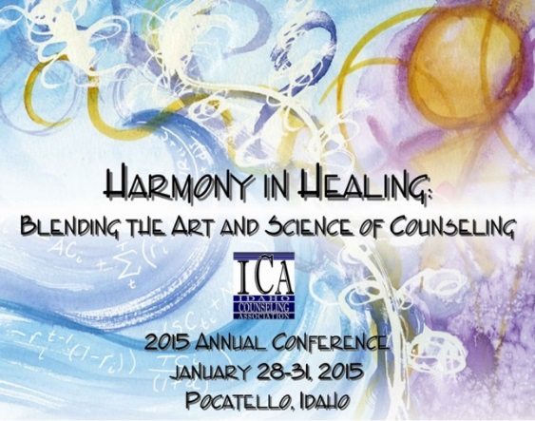
Idaho Counseling Association
Annual Conference
January 28-31, 2015

The Red Lion Convention Center

Pocatello, Idaho

Interest Session Proposal Form

Harmony in Healing: Blending the Art and Science of Counseling

Proposal Deadline: October 15, 2014

Notification of acceptance will be sent out by November 1, 2014
Please note: Incomplete proposals will be returned for completion

NO more than three (3) proposals may be submitted by any one presenter.

A professional quality headshot photograph and any credentials are required.

NOTE: Submission of this proposal constitutes acceptance of all conditions and terms INCLUDING A REQUIREMENT OF CONFERENCE REGISTRATION. The deadline for conference registration is December 31st, after which the proposal will be dropped.

**No more than 4 presenters per interest session please**
Primary Presenter #1  Name:  Credentials:  Address:  City:  Phone (w)  (h)  (f)  Email:  Website: | Presenter #2  Name:  Credentials:  Address:  City:  Phone (w)  (h)  (f)  Email:  Website:
Presenter #3  Name:  Credentials:  Address:  City:  Phone (w)  (h)  (f)  Email:  Website: | Presenter #4  Name:  Credentials:  Address:  City:  Phone (w)  (h)  (f)  Email:  Website:

Title of Program: (Limit to 20 Words)

Synopsis: Program Description as you want it to appear in marketing materials. This should include:
  - Clear summary. Information, techniques, theory, or research to be presented. (Limit to 40 words.)

  - Learning Objectives. What the audience can expect to learn. (3 to 4 condensed bulleted items)
Participants will:

(i.e. * learn art therapy techniques in theory and in application)

  - Method of the presentation
Panel Lecture Debate Demonstration Q & A

  - Relation to the theme of “Harmony in Healing: Blending the Art and Science of Counseling.”

This proposal is being submitted for:  Interest Session (90 minutes)  What level of clinician would be best served by your presentation?  Novice Professional (less than three years)  Advanced Professional (more than three years) | Audio-Visual Requests:  LCD Projector (will be provided)
Please check no more than two boxes for the division that would most benefit from your program:  School Counselors  Mental Health Counselors  Vocational/ Career Counselors  Marriage & Family Counselors  Counselor Educators & Supervisors  Ethics  Other: | Program Time Preference  Friday, Jan 30, a.m. Division Track Sessions  Friday, Jan 30, p.m. Division Track Sessions  Saturday, Jan 31, a.m. Ethics/Other Sessions  Saturday, Jan 31, p.m. Ethics/Other Sessions  Would you be willing to present more than once? (maximum of 2 presentations)  Yes  No

Please submit a brief biography for each presenter.

Please submit a passport quality photograph to be published in printed materials via e-mail. Failure to do so results in an incomplete proposal.

Special Requests or Needs:

2015 ICA Annual Conference
Presenter Agreement

Before submitting the above proposal, Presenters please read through the following agreement and sign and date below.

- Program Coordinator will send notification of accepted proposals by November 1, 2014.

- At least one presenter must be licensed as a Counselor with the State of Idaho. Presenters are limited to presenting no more than two (2) presentations.

- All presenters must register for the conference by December 31, 2014, after which the proposal will be dropped for those not registered.

- All rooms are set with movable chairs, theatre style, speaker's table, LCD projector, screen and AV table.

- It is the responsibility of presenter to provide computer and any audio equipment that they might need. Including any cables required to connect to the LCD projector.

- Internet access is not guaranteed.

- Presenters agree to the possibility of videotaping interest sessions for the use of continued education for ICA members only.

- Photographs and demographic information submitted may be used for recognition on the ICA website or printed materials. Higher resolution is better, but keep images less than 1 MB if possible.

- Presenters should come prepared with at least 50 copies of handouts to be distributed to attendees.

- Presenters will receive a summary of evaluations within 30 days after the conference.

- Presenters will be listed alphabetically, after primary presenter.

- Special needs or requests should be directed as soon as possible to the Program Coordinator.

- Program Coordinator will be notified as soon as possible of revisions, edits or cancellations. A letter of confirmation will be sent out in November to be reviewed and accepted by presenter.

Date:
Presenter Signature

Deadline for submission:

October 15, 2014
ICA 2015 Annual Conference
Program Coordinator
icapresentations@gmail.com

Questions may be directed to Michelle Carda-Hopkins, Program Coordinator at icapresentations@gmail.com

